Step 6. Body calibration validation
The body calibration must be validated to ensure it was completed properly. This validation should be done with the machine on a slope to ensure maximum accuracy.
Note: When calibrating a swing boom excavator, this step must be postponed to a later date. For a swing boom configuration, at least the measurement of the body and boom must be carried out. Only then will the values for body tilt and roll be displayed at the current machine angles.

1. Enter the Monitor Menu within the Web Interface app
2. Navigate to Machine Diagnostics
3. Navigate and open the Current Machine Angles section
4. Position the machine body into a repeatable position. This can be accomplished
with a straight edge by aligning the corner of the cab with the edge of track.
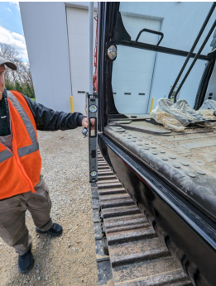
5. Record the Body Pitch and Roll from the Current Machine Angles section
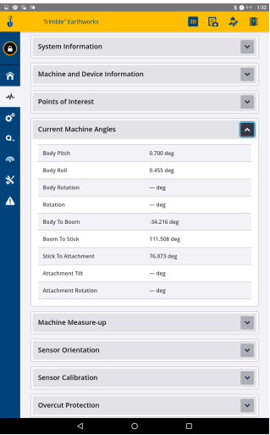
6. Rotate the machine 180 degrees and align the machine body in the same
fashion as step 4.
7. Record the Body Pitch and Roll measurements a second time.
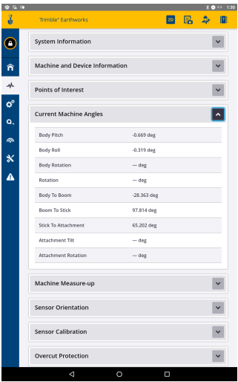
8. Compare the Body Pitch and Roll measurements you have recorded. They
should be within .020 (2/10ths) of each other with a difference in sign. If these
numbers are significantly different, repeat the steps within this section until the
body sensor is properly calibrated.

